FURKAN SAKIZLI · AI DATA ENGINEERING
GraphRAG must lead every answer back to the source
Why graph paths, text units, document versions and provenance must stay connected if a plausible answer is to become defensible evidence.
ESSAY · AI DATA ENGINEERING · 17 MIN READ · Furkan Sakızlı
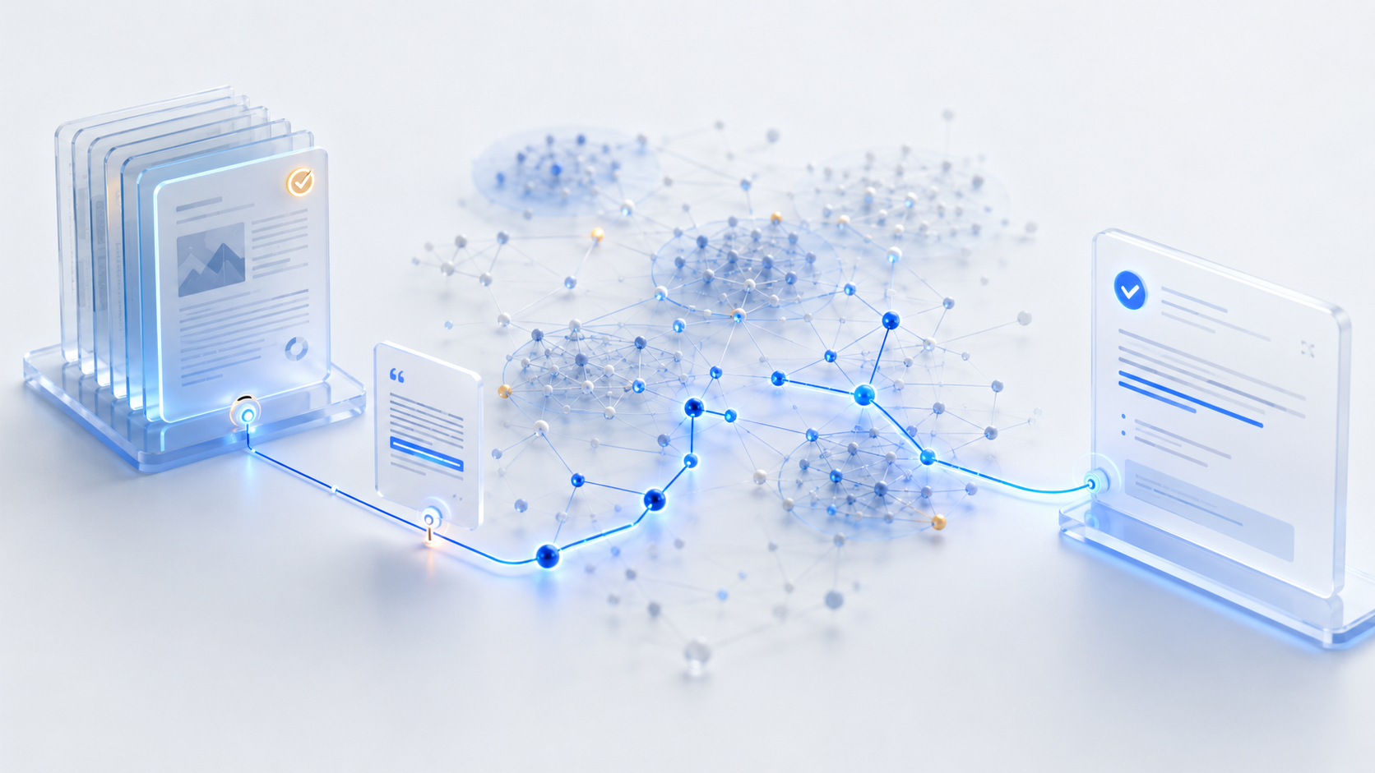
An answer is the end of a processing chain. Evidence exists only when that chain can be inspected in reverse all the way to a valid source.
GraphRAG can expose relationships that similarity search handles poorly. Entities connect, communities form, and corpus-wide questions can use a structured representation. This additional abstraction creates a responsibility: every statement must reveal which documents, text units, extractions and summaries produced it.
An impressive graph is not enough. Even clickable citations can be weak when they are merely topical, point to an obsolete version or fail to support the claim. Reliable GraphRAG is therefore not a one-way route from document to answer. It is a reversible evidence path: answer → claim → graph path → relation → text unit → document version → source.
The index is a chain of derived artefacts
The documented GraphRAG architecture produces several layers from raw text. Documents are split into text units. Entities, relationships and sometimes additional claims are extracted. Communities group graph regions and community reports summarise them. Query modes then use different combinations of those artefacts.
Every layer is useful but none is identical to the primary source. Entity labels may be normalised, relationships automatically phrased and reports generated from many passages. Errors can propagate. Each derived object therefore needs stable references to inputs, configuration and creation time. Without them, the index becomes a second knowledge base that may silently drift away from its sources.
Stable identities come before elegant graphs
A source path works only when objects have unique identities. A URL is rarely sufficient: content changes, filenames collide and policies exist in several editions. A robust system separates source, document, version, segment, entity and relationship identifiers.
The document version should be tied to the indexed bytes through a hash or comparable immutable identifier. Metadata should include title, publisher, creation and retrieval dates, language, validity, access scope and superseded versions. An update must not silently overwrite the prior edition. Otherwise the same path appears to remain valid even though its foundation has changed.
Text units need precise anchors
A segment is citable only when it can be found inside the source. Page, section, heading, paragraph or character offsets are possible anchors. HTML may require stable selectors or snapshots. Audio and video need timestamps; OCR should point back to the page image and, where possible, the recognised region.
The visible excerpt must not distort meaning. A sentence may depend on a limitation in the previous paragraph or belong to a counterexample. The system should expose neighbouring passages and document hierarchy. Chunking serves retrieval; it must not define the boundary of proof.
A relationship needs its own provenance
Edges look factual, yet they may come from explicit tables, curated rules, co-occurrence, statistical similarity or automatic extraction. Their origin fundamentally changes their meaning.
A relationship should carry type, direction, scope, extraction method, confidence and supporting passages. Support and conflict from multiple sources must remain distinct. Two passages mentioning the same entities do not demonstrate causation. An edge is a navigable analytical object; referenced passages enable professional judgement.
Entity resolution can improve or destroy the evidence path
Several names may identify one entity, while identical names may refer to different people, products or organisations. Entity resolution joins variants and prevents fragmentation. A false merge, however, connects unrelated sources and creates persuasive but invalid paths.
Alias rules, merge decisions and split corrections must be versioned. Critical identities benefit from human review. The query path should indicate whether identity came directly from a source, was algorithmically inferred or manually confirmed. Reversing a merge and recomputing dependent artefacts is a core architectural capability.
Community reports orient; they do not constitute primary evidence
Global Search uses community reports for corpus-wide questions. This is powerful because abstract prompts provide little direction for a single query vector. Reports, however, compress information that has already been extracted and compressed.
A global answer may have a long derivation chain. It should disclose which reports were considered, how intermediate responses were rated and which source regions ultimately mattered. A report can prioritise a search space, but it is often too distant to support a precise claim alone. Important claims must continue down to text units and original documents.
Local, Global and DRIFT create different evidence distances
Local Search combines graph data with text units around entities. Its source path is often short, although entity resolution and relation extraction can still fail. Global Search uses community reports and map-reduce-style aggregation, increasing evidence distance. DRIFT starts globally and develops local follow-up questions, combining several routes.
These modes need different citation rules. A local factual answer should cite concrete passages. A global synthesis should show covered communities, representative sources and dissenting positions. A DRIFT answer should record its follow-up sequence so reviewers can see why certain graph regions were explored and others discarded.
A link is not yet claim support
Citation quality is not measured by the number of links. Claim coverage matters: which passage truly supports which statement? An answer may list five sources and leave its central claim unsupported. Conversely, one authoritative primary source may be sufficient for a narrow claim.
Outputs should therefore be decomposed into testable claims. Each claim receives passages, relationship type, source status and limitations. Syntheses must distinguish direct evidence, multi-source inference and hypothesis. Claim-evidence mapping is more precise than a generic bibliography.
Provenance models entities, activities and responsibility
The W3C PROV family represents provenance through entities, activities and agents. GraphRAG can apply this practically: a document segment is an entity, extraction or summarisation is an activity, and a system or reviewer is the responsible agent. Artefacts can be represented as derived from others, generated by activities or attributed to agents.
The goal is not to retain every internal computation. It is to capture transitions relevant to quality, reproducibility and accountability: model and configuration versions, time, inputs, outputs, approvals and changes. A compact standards-aligned provenance graph can explain heterogeneous pipelines more clearly than scattered logs.
Permissions must accompany the entire path
If a user cannot access a source, a derived graph path must not disclose its confidential information. Access rules have to operate before retrieval and on derived artefacts. A community report built from public and restricted documents may itself be restricted.
The system needs inheritance, combination and reassessment rules. Citations and previews must not reveal blocked passages. At the same time, an authorised reviewer should see when a claim could not be fully verified because access was missing. Security and evidence transparency must be designed together.
Updating means invalidating, not merely adding
New documents alter communities, entity merges and summaries. A withdrawn source may affect many relationships and answer artefacts. Update processes need dependency awareness so that affected objects are marked stale, recomputed or blocked until review.
A full rebuild is simple but expensive. Incremental update is efficient but requires precise lineage. Both need reproducible index snapshots. An answer should identify its snapshot, explaining why queries at different times produce different results.
Evaluation begins at claim level
An answer may be fluent and poorly supported. Evaluation should test retrieval, graph construction, synthesis and provenance separately. Did retrieval find the right passages? Are entities resolved correctly? Do edges justify the asserted relation? Do citations cover claims? Are conflicts visible? Does the path survive an update?
Abstention tests are also necessary. When evidence is insufficient, the system must express uncertainty or refuse. NIST's Generative AI Profile supports risk-based testing, evaluation, verification and validation. For GraphRAG that means measuring not only answer quality but the reliability of the evidence chain and organisational controls.
Method: CLAIM → PATH → PASSAGE → VERSION → PROVENANCE → VERIFY
“CLAIM” decomposes the answer. “PATH” exposes entities, relations, communities and query steps. “PASSAGE” returns to concrete text. “VERSION” binds it to indexed content. “PROVENANCE” records extraction, derivation and responsibility. “VERIFY” checks support, counterevidence, permissions and freshness.
This reverse movement is the quality test. A claim that cannot return to a valid source remains a plausible output. GraphRAG becomes defensible knowledge infrastructure only when the route back to evidence is designed as carefully as the route to the answer.
Exercise: create a Source Return Map
Choose an answer containing at least three claims. Assign every claim a graph path, passages and exact document version. Mark extractions, community reports and summaries as derived artefacts. Add counter-sources, access state and expiry. Then remove one source from the index and document which claims and artefacts must be invalidated.
Sources and professional scope
• [Microsoft GraphRAG: Indexing Architecture](https://microsoft.github.io/graphrag/index/architecture/) – knowledge model, text units, entities, relationships, communities and reports.
• [Microsoft GraphRAG: Query Overview](https://microsoft.github.io/graphrag/query/overview/) – Local, Global, DRIFT, Basic Search and Question Generation.
• [Microsoft GraphRAG: Local Search](https://microsoft.github.io/graphrag/query/local_search/) – combining graph data with text units for entity-focused questions.
• [Microsoft GraphRAG: Global Search](https://microsoft.github.io/graphrag/query/global_search/) – corpus-wide synthesis based on community reports and map-reduce processing.
• [Microsoft GraphRAG: DRIFT Search](https://microsoft.github.io/graphrag/query/drift_search/) – global orientation with local follow-up questions.
• [W3C: PROV-O](https://www.w3.org/TR/prov-o/) – ontology for representing and exchanging provenance information.
• [NIST: Generative AI Profile](https://www.nist.gov/publications/artificial-intelligence-risk-management-framework-generative-artificial-intelligence) – risk-based testing, evaluation, verification and validation practices for generative AI.
*Scope:* Community reports, automatically extracted relationships and generated answers are derived artefacts. Citations and provenance improve inspectability but do not automatically guarantee that a claim is professionally correct. Editorial review date: 17 July 2026.

Working template: Source Return Map
Field | Entry
Claim / status
Graph path / query mode
Relation / extraction
Passage / anchor
Document / version
Provenance / permission
Counterevidence / invalidation

